***Selection Sort***

The **selection sort algorithm** sorts an array by repeatedly finding the minimum element (considering ascending order) from unsorted part and putting it at the beginning. The algorithm maintains two subarrays in a given array.

* The subarray which is already sorted.
* Remaining subarray which is unsorted.

In every iteration of selection sort, the minimum element (considering ascending order) from the unsorted subarray is picked and moved to the sorted subarray.

**Flowchart of the Selection Sort:** 

**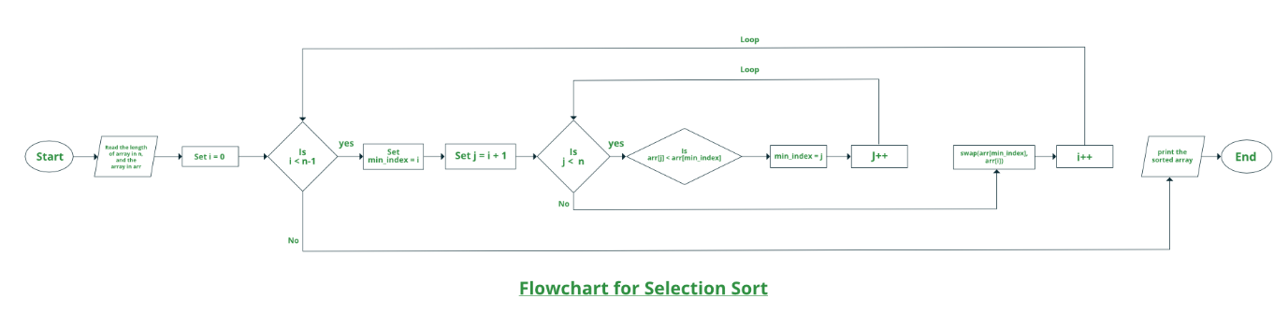  
How selection sort works?**

Lets consider the following array as an example: **arr[] = {64, 25, 12, 22, 11}**

**First pass:**

* For the first position in the sorted array, the whole array is traversed from index 0 to 4 sequentially. The first position where **64**is stored presently, after traversing whole array it is clear that **11**is the lowest value.

|  |  |  |  |  |
| --- | --- | --- | --- | --- |
| **64** | 25 | 12 | 22 | 11 |

* Thus, replace 64 with 11. After one iteration **11**, which happens to be the least value in the array, tends to appear in the first position of the sorted list.

|  |  |  |  |  |
| --- | --- | --- | --- | --- |
| **11** | 25 | 12 | 22 | 64 |

**Second Pass:**

* For the second position, where 25 is present, again traverse the rest of the array in a sequential manner.

|  |  |  |  |  |
| --- | --- | --- | --- | --- |
| 11 | **25** | 12 | 22 | 64 |

* After traversing, we found that **12** is the second lowest value in the array and it should appear at the second place in the array, thus swap these values.

|  |  |  |  |  |
| --- | --- | --- | --- | --- |
| 11 | **12** | 25 | 22 | 64 |

**Third Pass:**

* Now, for third place, where **25** is present again traverse the rest of the array and find the third least value present in the array.

|  |  |  |  |  |
| --- | --- | --- | --- | --- |
| 11 | 12 | **25** | 22 | 64 |

* While traversing, **22**came out to be the third least value and it should appear at the third place in the array, thus swap **22**with element present at third position.

|  |  |  |  |  |
| --- | --- | --- | --- | --- |
| 11 | 12 | **22** | 25 | 64 |

**Fourth pass:**

* Similarly, for fourth position traverse the rest of the array and find the fourth least element in the array
* As **25**is the 4th lowest value hence, it will place at the fourth position.

|  |  |  |  |  |
| --- | --- | --- | --- | --- |
| 11 | 12 | 22 | **25** | 64 |

**Fifth Pass:**

* At last the largest value present in the array automatically get placed at the last position in the array
* The resulted array is the sorted array.

| **11** | **12** | **22** | **25** | **64** |
| --- | --- | --- | --- | --- |

**Approach:**

* Initialize minimum value(min_idx) to location 0
* Traverse the array to find the minimum element in the array
* While traversing if any element smaller than **min_idx**is found then swap both the values.
* Then, increment min_idx to point to next element
* Repeat until array is sorted

Below is the implementation of the above approach:

C++Java

// Java program for implementation of Selection Sort

class SelectionSort

{

void sort(int arr[])

{

int n = arr.length;

// One by one move boundary of unsorted subarray

for (int i = 0; i < n-1; i++)

{

// Find the minimum element in unsorted array

int min_idx = i;

for (int j = i+1; j < n; j++)

if (arr[j] < arr[min_idx])

min_idx = j;

// Swap the found minimum element with the first

// element

int temp = arr[min_idx];

arr[min_idx] = arr[i];

arr[i] = temp;

}

}

// Prints the array

void printArray(int arr[])

{

int n = arr.length;

for (int i=0; i<n; ++i)

System.out.print(arr[i]+" ");

System.out.println();

}

// Driver code to test above

public static void main(String args[])

{

SelectionSort ob = new SelectionSort();

int arr[] = {64,25,12,22,11};

ob.sort(arr);

System.out.println("Sorted array");

ob.printArray(arr);

}

}

/* This code is contributed by Rajat Mishra*/

**Output**

Sorted array:

11 12 22 25 64